Group 00 RationalGRL

Page 2................ GRL Model constructed from discussion

Page 3................ All underlying arguments

Page 4................ Statistics of the annotation

Page 5................ Some general observations

Page 6-19......... Detailed discussion of GRL elements and their underlying arguments.

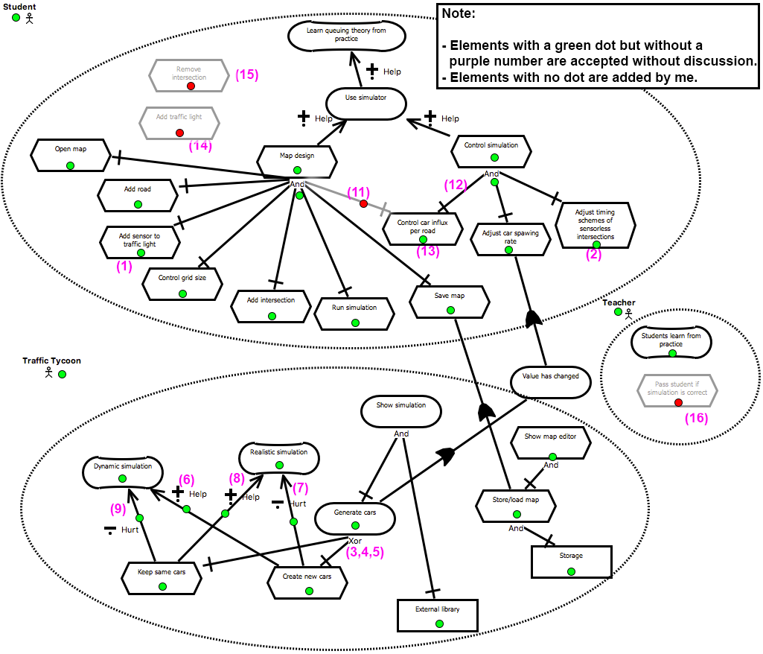

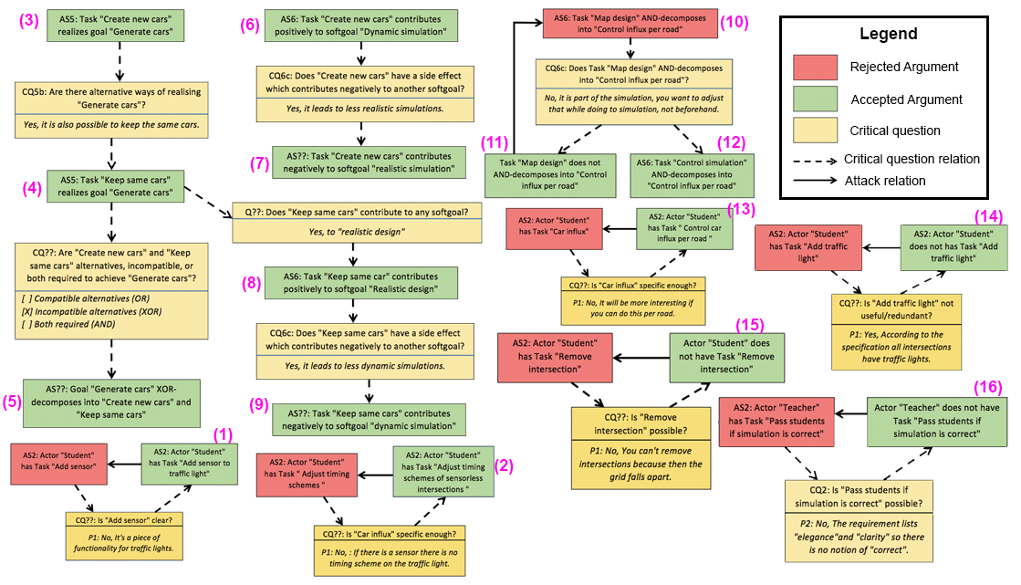

**Statistics**

|  |  |  |  |  |  |  |  |  |  |  |  |  |  |  |  |  |  |  |  |  |  |  |  |  |  |  |  |  |  |  |  |  |  |  |  |  |  |  |  |  |  |  |  |  |  |  |  |  |  |  |  |  |  |  |  |  |  |  |  |  |  |  |  |  |  |  |  |  |  |  |  |  |
| --- | --- | --- | --- | --- | --- | --- | --- | --- | --- | --- | --- | --- | --- | --- | --- | --- | --- | --- | --- | --- | --- | --- | --- | --- | --- | --- | --- | --- | --- | --- | --- | --- | --- | --- | --- | --- | --- | --- | --- | --- | --- | --- | --- | --- | --- | --- | --- | --- | --- | --- | --- | --- | --- | --- | --- | --- | --- | --- | --- | --- | --- | --- | --- | --- | --- | --- | --- | --- | --- | --- | --- | --- |
| |  |  |  | | --- | --- | --- | | **Argument Schemes** | **Found** | **Added** | | AS0: Actor | 2 |  | | AS1: Resource | 2 |  | | AS2: Task/action | 20 |  | | AS3: Goal |  | 1 | | AS4: Softgoal | 3 | 1 | | AS5: Task realizes goal | 4 |  | | AS6: Task contributes to softgoal | 6 |  | | AS7: Goal contributes to softgoal |  | 1 | | AS8: Resource contributes to task |  | 2 | | AS9: Actor depends on actor |  | 3 | | |  |  | | --- | --- | | **Critical questions** | **Found** | | CQ1: Is the resource available? |  | | CQ2: Is the task possible? | 2 | | CQ3: Can the desired goal be realized? |  | | CQ4: Is the softgoal legitimate? |  | | CQ5a: Will the task realize the goal? |  | | CQ5b: Are there alternative ways to realize the same goal? | 1 | | CQ6a: Are there alternative ways to contribute to the same softgoal? |  | | CQ6b: Does the task have negative side effects / same softgoal? |  | | CQ6c: Does the task have negative side effects / other softgoal? | 2 | | CQ6d: Does the task contribute to some other softgoal? |  | | CQ6e: Does the task preclude other task contributing to other softgoal? |  | | CQ7a: Does the goal contribute to the softgoal? |  | | CQ7b: Does the goal contribute to some other softgoal? |  | | CQ8a: Is the resource required in order to perform the task? |  | | CQ8b: Can other resources be used for the task? |  | | CQ8c: Is the resource required in order to perform the task? |  | | CQ8d: Does using the resource make other resources unavailable? |  | | CQ9: Does the actor depend on any actors? |  | |

|  |  |
| --- | --- |
| **Other annotations** | **Found** |
| GRL-related issue introduction (e.g., "what are the actors?") | 5 |
| General non-GRL-related issue discussion with alternatives and arguments (IBIS-style) | 3 |
| AS: Task x-decomposes into task (x in {XOR,AND,OR}) | 11 |
| AS: Task contributes negatively to softgoal | 2 |
| CQ: Is the task is useful/relevant? If no: remove task | 1 |
| CQ: Is the description of an IE clear? (clarification). If no: replace description | 1 |
| CQ: Is the description of the IE specific enough? If no: replace description | 2 |
| CQ: Does the task decompose into the other task? | 1 |
| CQ: What kind of decomposition (AND/OR/XOR)? | 1 |

**Some general observations**

* Our current argument schemes use "Task T realizes goal G", but the notion of "realizing" doesn't exist in GRL. It should be either:

1. "Goal G is decomposed into Task T1,...,Tn", or
2. "Task T1,...,Tn realize goal G"

* Both (1) and (2) do not make the type of decomposition explicit (AND, OR, XOR). This should be done through a critical question. For instance
  + AS??: Goal G is decomposed into Task T1 and T2
  + CQ??: Are task T1 and T2 both required (AND), compatible alternatives (OR), or incompatible alternatives (XOR)?
* We currently don't distinguish between positive and negative contribution in the both argument schemes and the critical questions. This should be added. Other AS and CQ should be added as well (see statistics).
* It seems that besides "critical questions" it also would be useful to have questions that stimulate a discussion. These are simply questions asking about specific parts of the goal model. For instance:
  + (Actor) What are the actors of the system?
  + (Goal) What are the goals of actor A?
  + (Goal realization) Which tasks realize goal G?
  + (Task contributes to softgoal) Does task T contribute to any softgoal?
  + ..
* It is not clear yet in general way the effect is of answering a critical question. This can be different things: An element is disabled, an element is refined, a link is disabled and another link appear, etc. When we finished all the analysis we should classify this more precisely.
* Idea: group arguments by "topic"

**Defining the Actors**

*The participants start by stating the actors. There's no discussion about this. Why they name the system "Traffic Tycoon", they refer to it with "Simulator" through the rest of the discussion.*

|  |  |  |
| --- | --- | --- |
| Respondent | Text | Annotation |
|  | First recording 50:44 |  |
| 0:00:10.2  PERSON 1 | So, yeah [pause] I would start with something about the context. That we have to determine who the users of the system are gonna be, stakeholders. | **[1 issue]** What are the actors? |
| 0:00:43.7  PERSON 2 | Mhm yeah, they are students | **[2 actor (AS?)]** Student |
| 0:00:56.4  PERSON 1 | There’s still the teacher and the stakeholder as well | **[3 actor (AS?)**] Teacher |
|  |  |  |
| 0:13:25.9  PERSON 1 | Yeah? [inaudible] Ok. So yeah, so basically that’s a proper name [inaudible] |  |
| 0:13:52.8  PERSON 2 | [laugh] Traffic tycoon. | **[17 actor (AS??)]** Traffic tycoon |

GRL Element Underlying Arguments (None)

 *None*

MacintoschHD:Users:marc.vanzee:Desktop:Screen Shot 2016-12-14 at 16.43.49.pngMacintoschHD:Users:marc.vanzee:Desktop:Screen Shot 2016-12-14 at 16.38.18.png

**Softgoal and Rejected Task of Actor "Teacher"**

*They discuss the goals of Teacher. Initally, one of the participants believes the students have to hand in an exercise that will be graded. However, they derive from the problem specification that this is not possible. This can be formalized as one of our critical questions.*

|  |  |  |
| --- | --- | --- |
| 0:00:59.3  PERSON 1 | Because they’re probably gonna get graded. Do we have to make assumptions about something for the teacher? | **[4 issue]** What are the goals of Teacher? |
| 0:01:12.7  PERSON 2 | [inaudible] She want them to learn from practice that-- | **[5 softgoal (AS4)]** Teacher wants students to learn from practice |
| 0:01:31.9  PERSON 1 | So it actually is basically if it works you get a pass. I guess. Right? | **[6 task (AS2)]** Teacher passes students if simulation is correct |
| 0:01:48.8  PERSON 2 | Well this lists elegance and clarity as a-. So what is meant by elegance and clarity is kind off an assumption of - | **[7 critical question CQ2 for 6]**  Is task "pass students if simulation is correct" possible?  **[8 answer to 7]:** No: the requirements list "elegance" and "clarity" for simulation, so it isn't possible to judge whether a simulation is correct or not.  **[8a remove task 6]** |

GRL Element Underlying Arguments (AS2: Impossible Task)

**MacintoschHD:Users:marc.vanzee:Desktop:Screen Shot 2016-12-14 at 16.39.17.png**

AS2: Actor "Teacher" has Task "Pass students if simulation is correct"

Actor "Teacher" does not have Task "Pass students if simulation is correct"

**Actor "Simulator": Trade-off**

*A trade-off is discussed between the behavior of the cars in the simulation. Should the cars appear at the other side of the screen when they disappear, or should the cars appear randomly? Our formalization of the arguments contains quite some interpretation, but this is practically unavoidable since we cannot know what the participants were thinking about when they uttered the phrases.*

|  |  |  |
| --- | --- | --- |
| 0:06:36.0  PERSON 1 | Yeah, performance versus, I don’t know, functionality. Like, what you say, cars come out at the end of the map side is performance wise and, I don’t know, easier to make but it is less functional. Because you can’t see traffic flows that easy because, well there’s fixed amount of cars so there’s not really gonna be jams. Is there around Utrecht always the same amount of cars? | **[10 tradeoff]:  [10a softgoal (AS4)]** "dynamic simulation" to Simulator **[10b softgoal (AS4)]** "simple design" to Simulator **[10c task (AS2)]** "Generate cars" to Simulator **[10c task (AS2)]** "Create news cars" to Simulator **[10d task (AS2)]** "Keep same cars" to Simulator  **[10e contribution (AS6)]** "Create new cars" contributes positively to "Dynamic simulation"  **[10f contribution (AS6)]** "Create new car" contributes positively to "simple design" **[10g contribution (AS6)]** "Keep same cars" contributes negatively to "dynamic simulation"  **[10h contribution (AS6)]** "Keep same cars" contributes negatively to "simple design".  **[10g task decomposition (AS??)]** "Generate cars" XOR-decomposes into "Create new cars" and "Keep same cars" |

GRL Element Underlying Arguments

AS5: Task "Create new cars" realizes goal "Generate cars"

CQ5b: Are there alternative ways of realising "Generate cars"?

*Yes, it is also possible to keep the same cars.*

AS5: Task "Keep same cars" realizes goal "Generate cars"

CQ??: Are "Create new cars" and "Keep same cars" alternatives, incompatible, or both required to achieve "Generate cars"?

*[ ] Compatible alternatives (OR)  
[X] Incompatible alternatives (XOR)  
[ ] Both required (AND)*

AS??: Goal "Generate cars" XOR-decomposes into "Create new cars" and "Keep same cars"

AS6: Task "Create new cars" contributes positively to softgoal "Dynamic simulation"

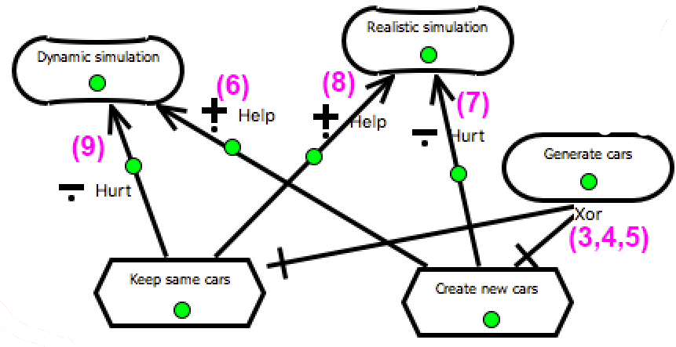

AS6: Task "Keep same car" contributes positively to softgoal "Realistic design"

CQ6c: Does "Keep same cars" have a side effect which contributes negatively to another softgoal?

*Yes, it leads to less dynamic simulations.*

AS??: Task "Keep same cars" contributes negatively to softgoal "dynamic simulation"

AS??: Task "Create new cars" contributes negatively to softgoal "realistic simulation"

Q??: Does "Keep same cars" contribute to any softgoal?

*Yes, to "realistic design"*

CQ6c: Does "Create new cars" have a side effect which contributes negatively to another softgoal?

*Yes, it leads to less realistic simulations.*

**Actor "Student"**

*The participants spent most time analyzing the actions of the student. It is not always clear whether these actions belong to actor "Student" or the actor "Simulator". Some tasks are immediately accepted, others rejected, and others rephrased.*

**Student: Immediately Accepted Tasks**

|  |  |  |
| --- | --- | --- |
| 0:07:12.1  PERSON 2 | Kind of want to increase the spawning rate- | **[15 task (AS2)]** "adjust car spawning rate" to Student |
| 0:14:52.6  PERSON 2 | So you what you kind of want is the use of a kind of simple map editor | **[19 task]** "Provide map editor" of Simulator |
| 0:15:11.2  PERSON 1 | And then, we have a set of actions. Save map, open map, add intersection, roads | **[20 task (AS2)]** Student has tasks "save map", "open map", "add intersection", "add road", "remove intersection" |
| 0:17:25.0  PERSON 2 | Yeah, so essentially it’s always a grid of a certain size. You control the size of it. | **[25 task (AS2)]** Task "control grid size" for Student |
| 0:21:33.3  PERSON 2 | When you’re running a simulation you also want to control traffic | **[27 task (AS2)]** Students has task "control traffic when running a simulation" |

GRL Element Underlying Arguments (None)

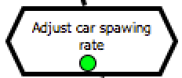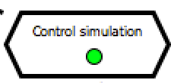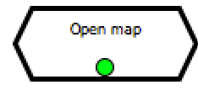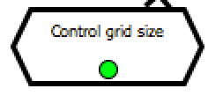**Student: Rejected Task**

|  |  |  |
| --- | --- | --- |
| 0:14:57.0  PERSON 2 | The simple intersections, simple traffic lights. Those are things you want to be able to add through a map editor | **[20 task (AS2)]** Student has task "add traffic light" |
| 0:15:42.3  PERSON 1 | Well, all intersection should have traffic lights so it’s | **[21 critical question CQ?? for 20]** "Is the task "Add traffic light" useless/redundant?  **[22 answer to 22]** Not useful, because according to the specification all intersections have traffic lights.  **[22a remove task]** Remove "add traffic light" |
| 0:15:44.9  PERSON 2 | Yeah |
| 0:15:45.2  PERSON 1 | It’s, you don’t have to specifically add a traffic light because if you have |

GRL Element Underlying Arguments (AS2)

**Student: Rejected Task**

CQ??: Is "Add traffic light" not useful/redundant?

*P1: Yes, According to the specification all intersections have traffic lights.*

AS2: Actor "Student" does not has Task "Add traffic light"

AS2: Actor "Student" has Task "Add traffic light"

|  |  |  |
| --- | --- | --- |
| 0:15:52.3  PERSON 1 | An intersection there is always gonna be a traffic light because it’s a constraint of the system. Alright. And on the technical side it’s gonna be a real pain to remove one intersection you’re gonna have to remove a lot more because there are only four-ways allowed and if you remove one intersection then- | **[23 critical question CQ2 for 20]** Is the task "Remove intersection" possible?  **[24 answer to 22]** It is going to be very difficult to implement.  **[24a remove task]** Remove task "remove intersection" |
| 0:16:16.7  PERSON 2 | Then this road is going nowhere. |
| 0:16:18.7  PERSON 1 | You can’t actually remove intersections in the middle because then the heel, entire grid falls apart |

GRL Element Underlying Arguments (AS2)

**Student: Rephrased Task**

CQ??: Is "Remove intersection" possible?

*P1: No, You can't remove intersections because then the grid falls apart.*

Actor "Student" does not have Task "Remove intersection"

AS2: Actor "Student" has Task "Remove intersection"

|  |  |  |
| --- | --- | --- |
| 0:22:23.1  PERSON 1 | Yeah, I’m not either. So yeah ok, so we have to be able to change the timings or it could also be on sensors or red somewhere. So you have to be able to put a sensor, like, here’s the sensor for this traffic light | **[28 task (AS2)]** Student has task "Add sensor" |
| 0:22:40.5  PERSON 2 | Ok yeah, so add sensor would be it then, a piece of functionality | **[29 critical question CQ?? for 28]** Is the task description clear? (clarification) |
| 0:22:52.8  PERSON 1 | For traffic lights. And run simulation basically. We also have to be able to change the inflow of cars. How many card come out in here on the side | **[30 answer to 34]** No. New description: "Add sensor to traffic light" |

GRL Element Underlying Arguments (Clarification)

AS2: Actor "Student" has Task "Add sensor to traffic light"

AS2: Actor "Student" has Task "Add sensor"



CQ??: Is "Add sensor" clear?

*P1: No, It's a piece of functionality for traffic lights.*

**Student: Rephrased Task**

|  |  |  |
| --- | --- | --- |
| 0:23:20.4  PERSON 1 | So, sets, yeah, car influx | **[32 task (AS2)]** Student has task "car influx" |
| 0:23:41.2  PERSON 2 | We’re talking about a context trade-off. If you can only control the set amount of influx from any side of this sort of random distribution, I think that is going to be less interesting than when you can say something like, this road is frequently traveled. | **[33 critical question CQ?? on 36]** Is the task description specific/clear enough?  **[34 answer to 37]** No, it is not clear where the influx is changing. Change to "control car influx per road" |
| 0:24:04.0  PERSON 2 | So yeah, we kind of want to keep this simple but I think if you make it completely random then it’s too simple, not useful |  |
| 0:24:12.3  PERSON 2 | So setting it per road, I think is something we want | **[34a rename]** "car influx" becomes "control car influx per road" |

GRL Element Underlying Arguments (Specificy)

AS2: Actor "Student" has Task " Control car influx per road "

AS2: Actor "Student" has Task "Car influx"

**Student: Rephrased Task**

CQ??: Is "Car influx" specific enough?

*P1: No, It will be more interesting if you can do this per road.*

|  |  |  |
| --- | --- | --- |
| 0:25:57.9  PERSON 2 | And then we have here able to adjust the timing schemes. | **[35 task (AS2)]** Student has task "adjust timing schemes" |
| 0:26:04.3  PERSON 2 | We got the sensors but- |  |
| 0:26:09.7  PERSON 1 | Yeah well, always with. I was thinking, you can eh, so I was thinking making the assumption that if there is a sensor there is no timing scheme. | **[36 critical question (CQ??)]** Is the task "adjust timing schemes" specific enough?  **[37 answer to 40]** No, only if there is no sensor.  **[37a rename]** "adjust timing schemes" becomes "adjust timing schemes of sensorless intersections" |

GRL Element Underlying Arguments (Specificy)

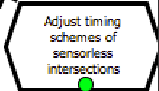**Student: Task Decomposition**

CQ??: Is "Adjust timing schemes" specific enough?

*P1: No, : If there is a sensor there is no timing scheme on the traffic light.*

AS2: Actor "Student" has Task "Adjust timing schemes of sensorless intersections "

AS2: Actor "Student" has Task " Adjust timing schemes "

*The participants first listed a large number of tasks for the Student, and then grouped them under two more general tasks, namely "Map design" and "Control simulation". The students were drawing this on paper, so it was difficult to infer it from a specific part of the text, but it followed from their general discussion.*

|  |  |  |
| --- | --- | --- |
| 0:32:29.1  PERSON 2 | Mhm |  |
| 0:32:29.8  PERSON 1 | I guess. This is map design, this is map design. The centers, do we call it map design? | **[38a task (CQ2)]** Student has task "Map design" |
| 0:32:36.4  PERSON 2 | I would say so yes | **[39 decomposition (AS??)]** Task "Map design" AND-decomposes into add road, add sensor to traffic light, control grid size, add intersection, open map, save map, adjust car spawning rate  **[*]** *Note: students are drawing here so they don't mention these explicitly.* |

GRL Element Underlying Arguments

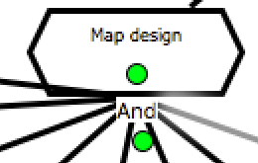**Student: Changing a Task Decomposition**

*When discussing which tasks should fall under "Map design" and which under "Control simulation", they changed their mind on "control car influx per road".*

|  |  |  |
| --- | --- | --- |
| 0:32:37.7  PERSON 1 | Ok. So these two ook, the influx per X roads | **[40 critical question (CQ??) for 39]** Does "map design" decompose into "control car influx per road"?  **[41 answer to 40]** No, it is part of the simulation.  **[42a task (AS2)]** Student has task "Control simulation"  **[42b decomposition]** "Control simulation AND-decomposes into "control car influx per road" |
| 0:32:42.2  PERSON 2 | Maybe that’s a part of the simulation already |
| 0:32:44.0  PERSON 2 | Because you want to adjust that while doing a simulation. Not beforehand |
| 0:32:48.9  PERSON 1 | Yeah |

GRL Element Underlying Arguments

AS6: Task "Map design" AND-decomposes into "Control influx per road"

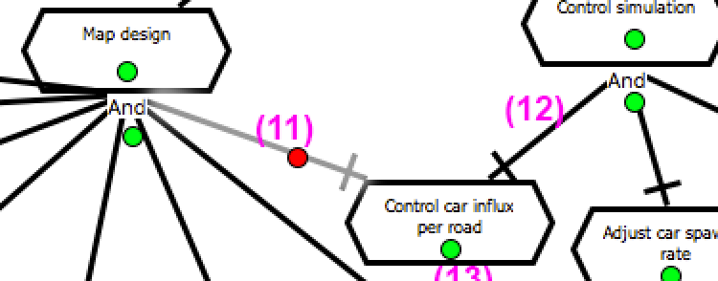**Discussions about non-GRL related issues -- Out of Scope**

AS6: Task "Control simulation" AND-decomposes into "Control influx per road"

Task "Map design" does not AND-decomposes into "Control influx per road"

CQ6c: Does Task "Map design" AND-decomposes into "Control influx per road"?

*No, it is part of the simulation, you want to adjust that while doing to simulation, not beforehand.*

*Some discussions between the participants were not traceable to elements of a goal model. However, they did help them to understand the problem domain better. We leave these out of scope for now. These could potentially be formalized using IBIS.*

|  |  |  |
| --- | --- | --- |
| 0:17:53.2  PERSON 2 | Unless you can put them on an angle while still being four-ways | **[26 issue]** Should four-way intersections under angles be allowed? |
| 0:18:01.2  PERSON 1 | Yeah true, but when you get crap everywhere [laugh]. I mean it could still work | **[26 option a]** No, it will become very complicated |
| 0:18:11.2  PERSON 2 | Yeah does the simulation change in any ways. I mean that’s kind of an abstraction of this, so. We can definitely do this, you’ll make things slightly more difficult because intersections where different roads, a la V-shape come together. That becomes hardly more problematic. So it definitely does change the flow of traffic. | **[26 option b]** Yes, it changes the flow of traffic, leading to more interesting behavior |
| 0:18:32.4  PERSON 1 | Yeah, but it should be simple, not scientifically correct. | **[26 argument 1 attacking b]** It should be simple, not scientifically correct |
| 0:20:31.7  PERSON 2 | Well I’m gonna write yours down then. That’s square. Let me [inaudible] | **[26 decision]** No. It should be simple, not scientifically correct |

|  |  |  |
| --- | --- | --- |
| 0:30:06.6  PERSON 2 | So, one main thing I would say is the map editor. So editing map as well as a functional block I would say | **[38 issue]** Should the Simulator consist of two separate components "Map Editor" and "Simulation"? |
| 0:30:19.7  PERSON 1 | Yeah well, I was thinking that as well, but I’m also with [NAME] looking at that architecture tool now and basically, it’s so closely related because 90% of the actions that you do. Because were in simulation [inaudible], is the only one here not doing it in an editor. And you’re always fine tuning all the settings to see what happens and run another simulation. So to really split that up- | **[38 option a]** No, the actions in both components are similar and the user is constantly switching between the two views. |
| 0:30:51.2  PERSON 2 | Mhm |  |
| 0:30:51.7  PERSON 1 | I mean on the functional level, true, there is a difference between editing and running but- | **[38 option b]** Yes, on the functional level there is a difference between editting and running |
| 0:30:57.4  PERSON 2 | Well we can make that into two giant blocks | **[38 decision]** Yes |